MOUNT KENYA UNIVERSITY
ADVANCED WEB DESIGN
STUDENT NAME:MASLAH ALI
ADMISSION NUMBER:BSCCS/2024/55884
UNIT CODE:BIT3208
UNIT NAME:ADVANCED WEB DESIGN AND DEVELOPMENT
LECTURER NAME: MR NYORO
ACADEMIC YEAR:YEAR 3 SEM 1

PROJECT DETAILS
PROJECT TITLE:BOOKING ONLINE SITE(ISIOLO RAHA BUS)
TECHNOLOGIES TO BE USED:PHP AND MySQL

TABLE OF CONTENT
Contents
WEEK 1:LOCAL ENVIRONMENT SETUP 2
Fig 1:installation of XAMPP 3
Fig 2:Apache and MySQL running 3
Fig 3:Localhost Test Page 4
Fig 4: Hello word test 5
Fig 5: Test Database connection 5
WEEK 2: WIREFRAMES AND GUI DESIGN 5
Fig 1:Login/Homepage 7
Fig 2:Dashboard Layout Design 8
Fig 3:Mobile View Mockup 9
Fig 4:Color Theme and Navigation Structure 9
Fig 5:Gui Protype in Figma 9
WEEK 3: JAVASCRIPT AND PHP BASICS 10
Fig 1:Javascript Form Validation 11
Fig 2:Password Strength Checker 11
Fig 3:PHP Syntax Practice 12
Fig 4:Database Connection Script 12
Fig 5:Dynamic User Input Handling 12
WEEK 4: Server-Side Component and Backend Development Foundations 13
TASK 1:Understanding server-side programming 13
Fig 1: Simple PHP processing page 14
Fig 2:Dynamic welcome page 15
Fig 3:Form submission system 16
TASK 2-HTML Forms and PHP Integration 16
Fig 4:Registration form 17
Fig 5:Login form 18
Fig 6:Contact form 19
Task 3-Simple Authentication System 19
Fig 7:Basic login page 20
Fig 8:Username validation 20
Fig 9:Session-based welcome page 22
WEEK 5: DATABASE COMPONENTS AND CRUD OPERATION 22
tables TASK 3-creating 22
Fig 2:students table 23
Task 4-Crud operation 23
Fig 3:Adding new user 25
Fig 4:view all users 26
Fig 5:update user 27

WEEK 1:LOCAL ENVIRONMENT SETUP
TITLE: Installation and Testing of Local Development Environment
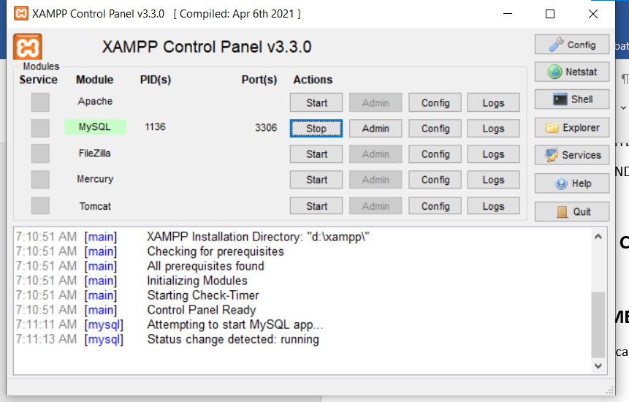

Fig 1:installation of XAMPP


Fig 2:Apache and MySQL running

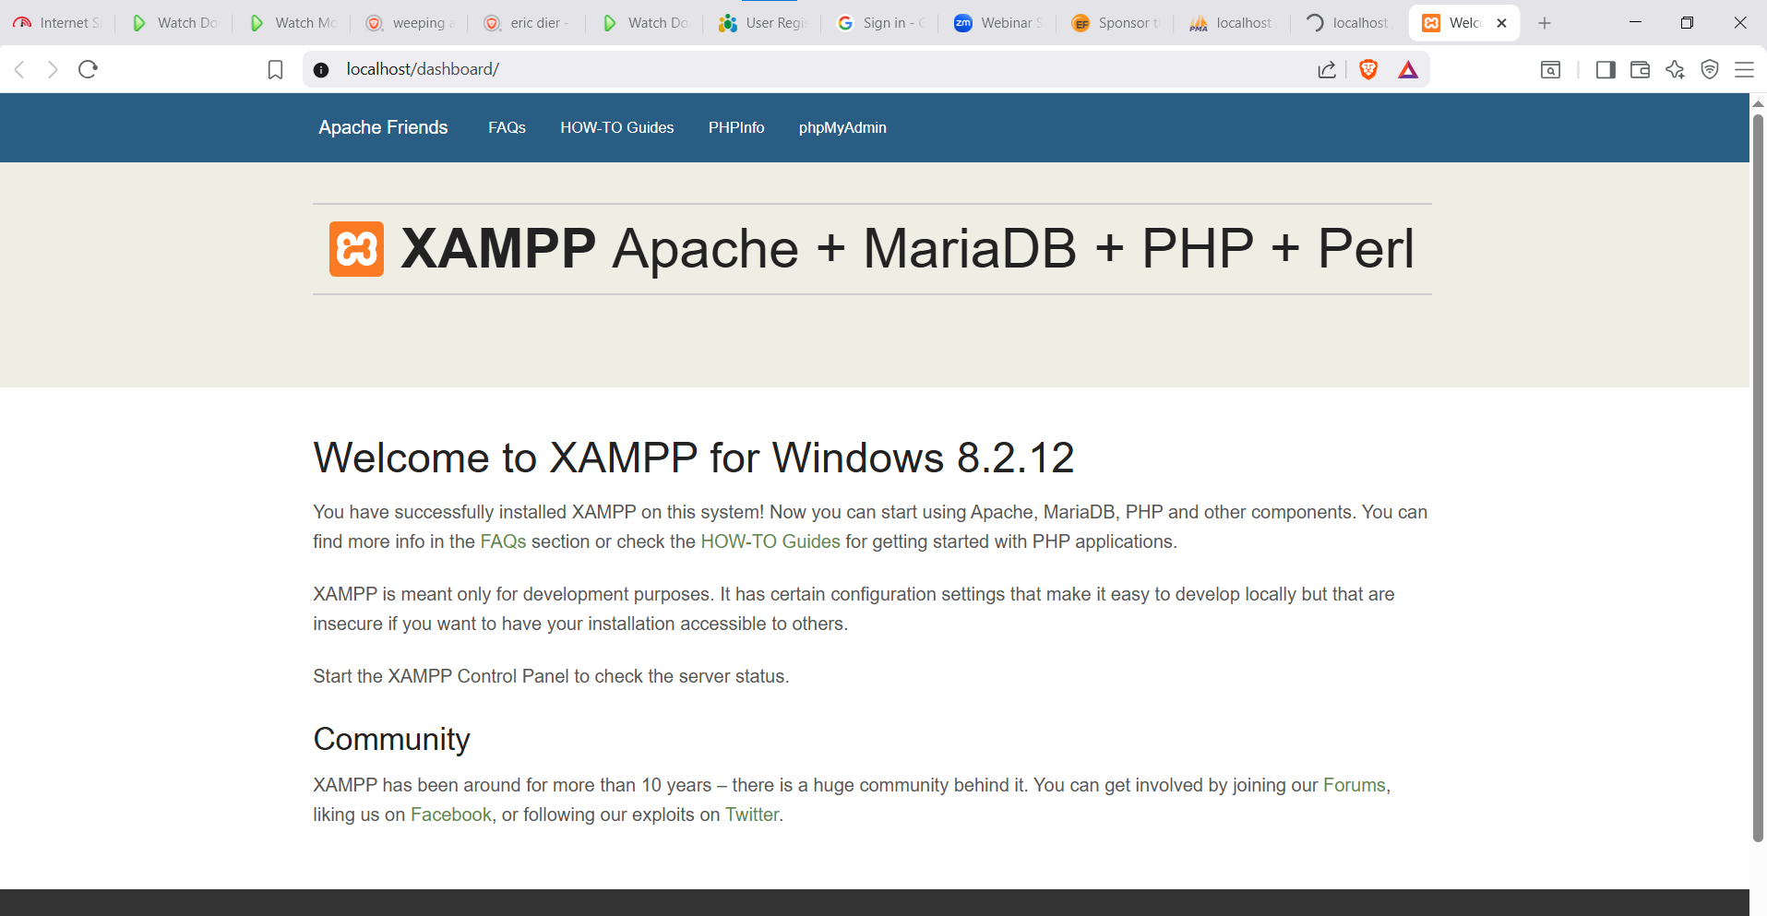

Fig 3:Localhost Test Page
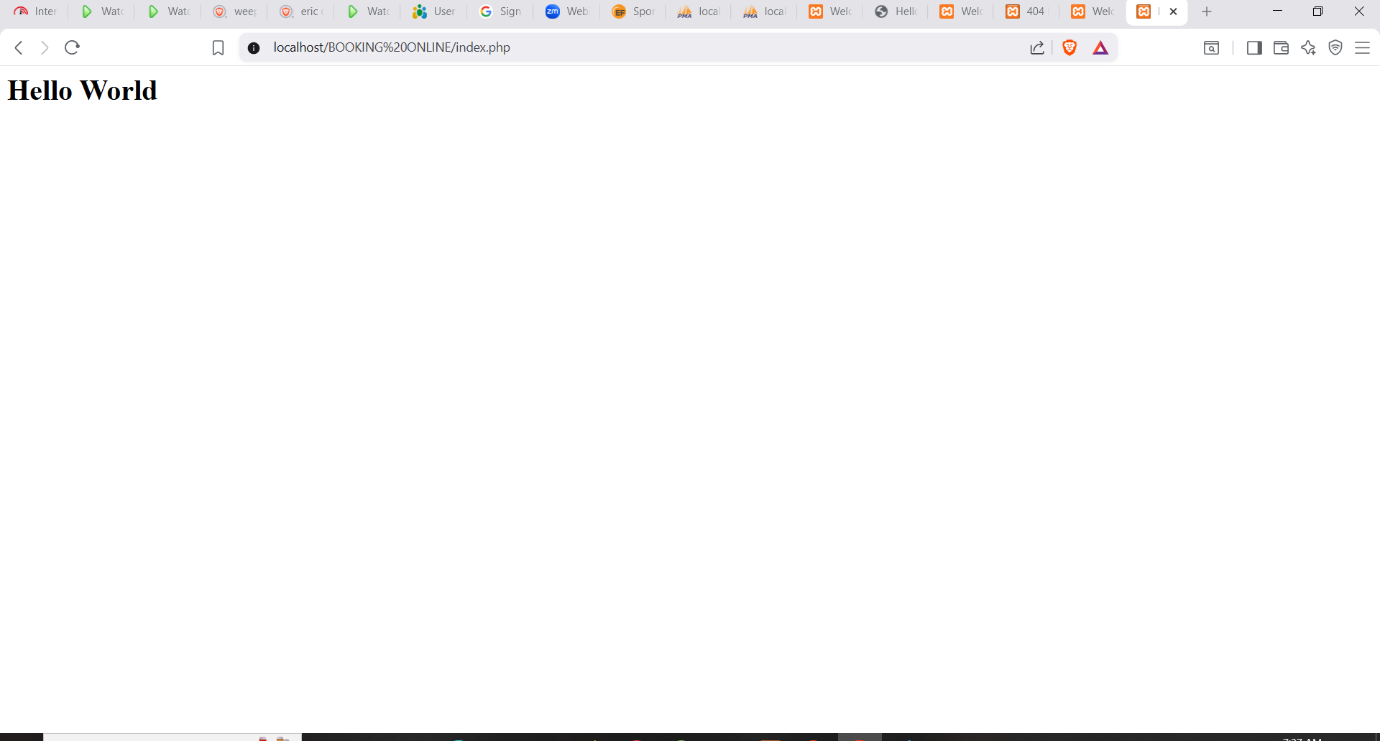

Fig 4: Hello word test
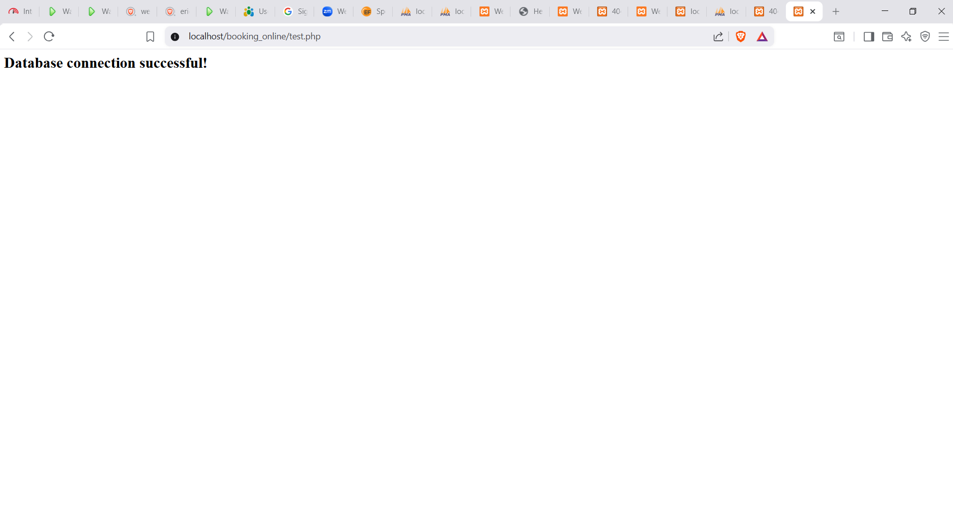

Fig 5: Test Database connection
WHAT I LEARNED: I learned how to set up and use XAMPP to run PHP files locally using Apache and MySQL. I created a project folder in htdocs and tested HTML and PHP pages. I also learned how to create a MySQL database using phpMyAdmin and connect it to PHP using MySQL.
TECHNOLOGIES USED: The technologies used were HTML, PHP, MySQL, and XAMPP server.
CHALLENGES ENCOUNTERED: The main challenge I faced was file path errors and “Not Found” issues, which were solved by placing files in the correct htdocs folder.
WHAT THE SCREENSHOTS DEMONSTRATE: The screenshots demonstrate successful webpage execution and database connection.

WEEK 2: WIREFRAMES AND GUI DESIGN
TITLE: User Interface Planning and System Design
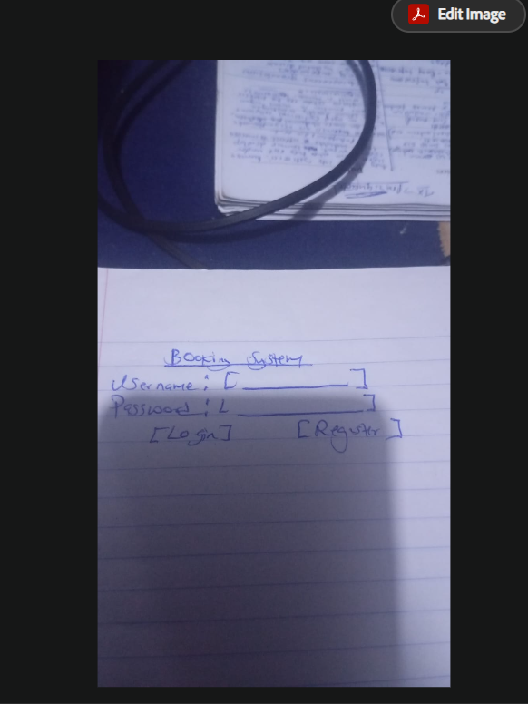

Fig 1:Login/Homepage
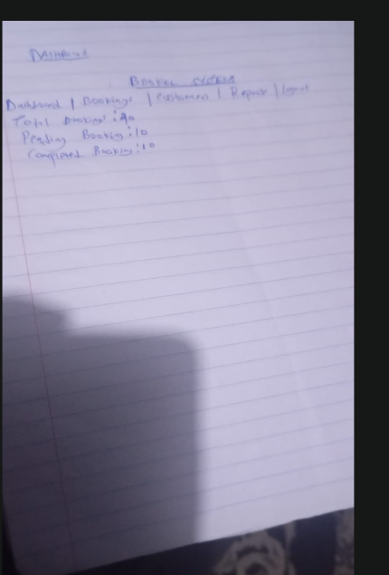

Fig 2:Dashboard Layout Design
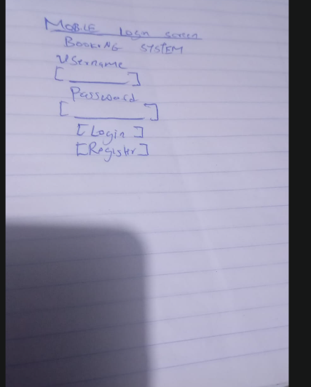

Fig 3:Mobile View Mockup
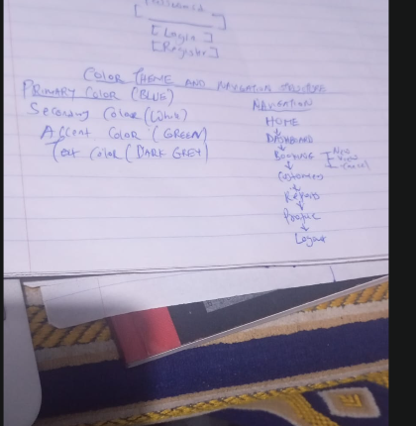

Fig 4:Color Theme and Navigation Structure
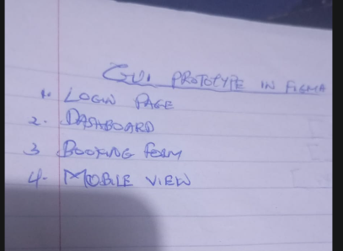

Fig 5:Gui Protype in Figma

Why the design was selected: The design was selected because it is simple, organized, and easy to use for both customers and administrators.
User experience considerations: User experience was considered by using clear labels, intuitive navigation, and a clean layout that helps users complete tasks quickly.
How navigation flow was planned: The navigation flow was planned to guide users logically from login to the dashboard, bookings, reports, and logout functions. This structure reduces confusion and improves efficiency.
Intended System Users: The intended system users are customers who make bookings and administrators who manage booking records, customer information, and reports. The design aims to provide a smooth and user-friendly experience for all users.

WEEK 3: JAVASCRIPT AND PHP BASICS
TITLE: Fronted and Backend Foundation
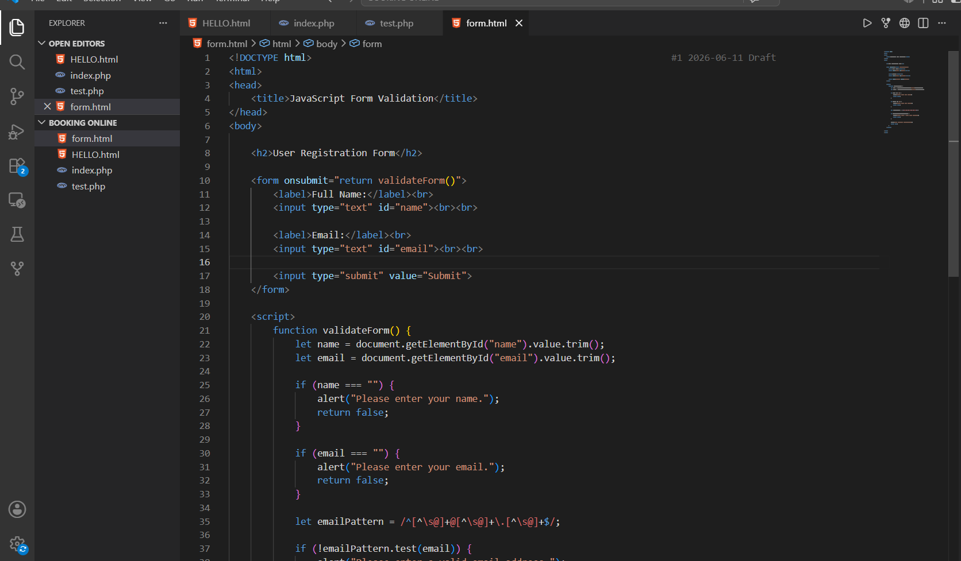

Fig 1:Javascript Form Validation
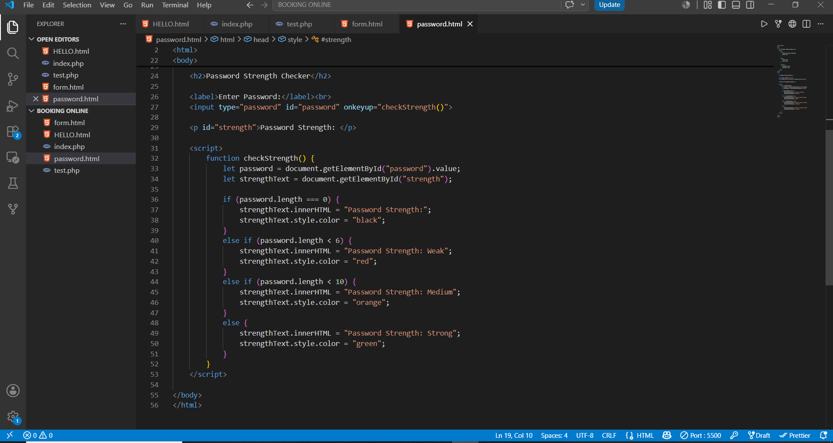

Fig 2:Password Strength Checker
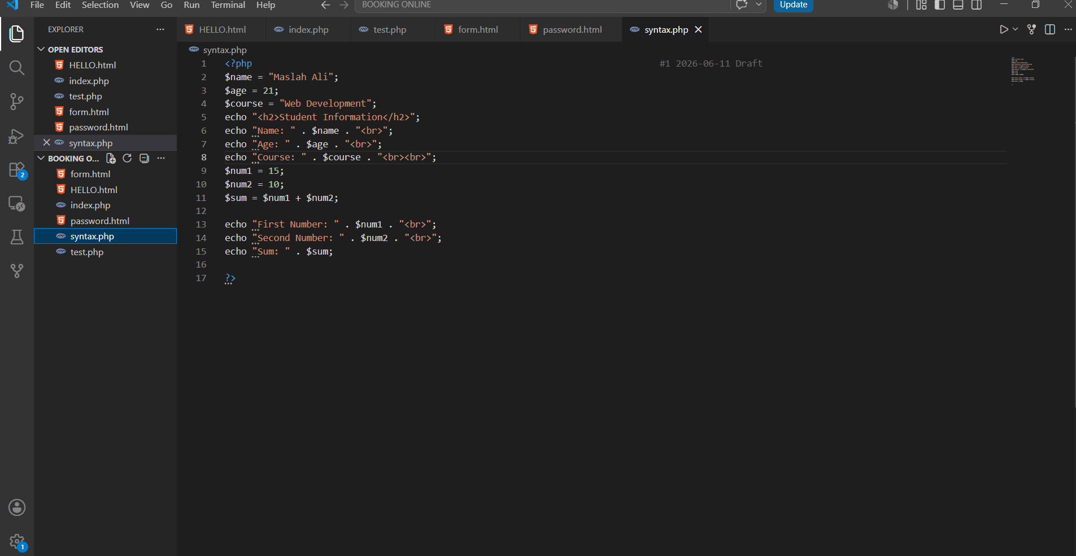

Fig 3:PHP Syntax Practice
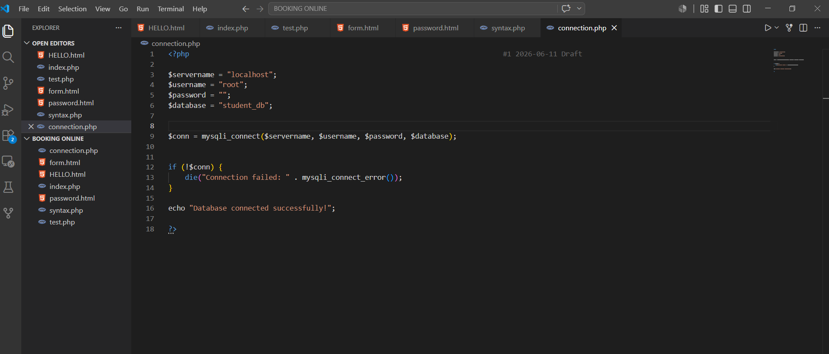

Fig 4:Database Connection Script
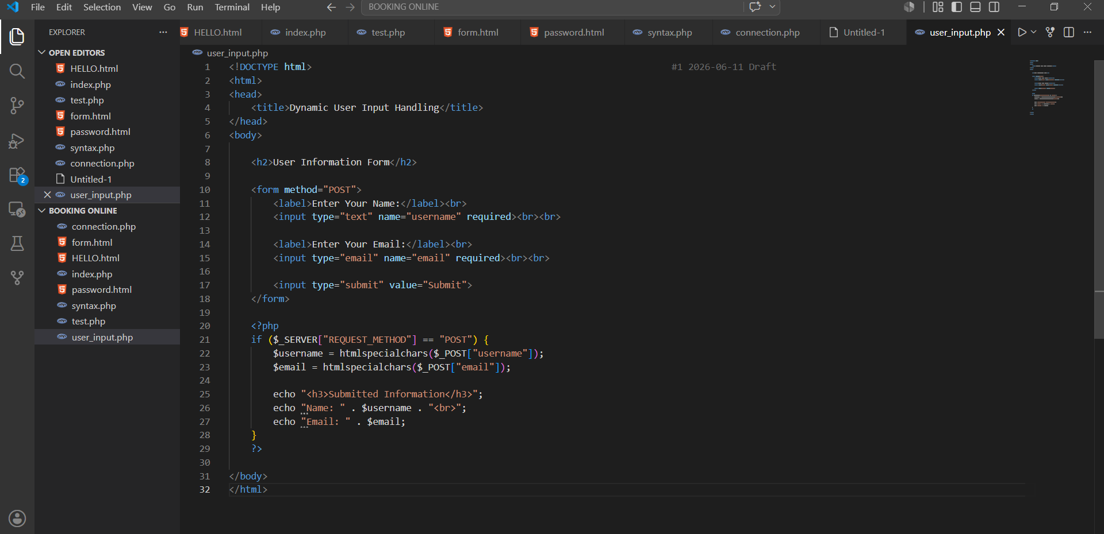

Fig 5:Dynamic User Input Handling
How Fronted and Backend interact: During this week, I learned how frontend and backend technologies work together to create interactive web applications.
Purpose Of Validation: Validation is important because it helps prevent incorrect or incomplete information from being processed. On the backend, PHP handled user data and communicated with the database.
Why Database connection matters: Database connections are essential because they allow applications to store, retrieve, and manage information efficiently.
Technology Used: The technologies used in this practical included HTML, JavaScript, PHP, MySQL, and XAMPP for local web server and database management.

WEEK 4: Server-Side Component and Backend Development Foundations

TASK 1:Understanding server-side programming
Main Goal: Introduced backend processing and real user interaction systems.
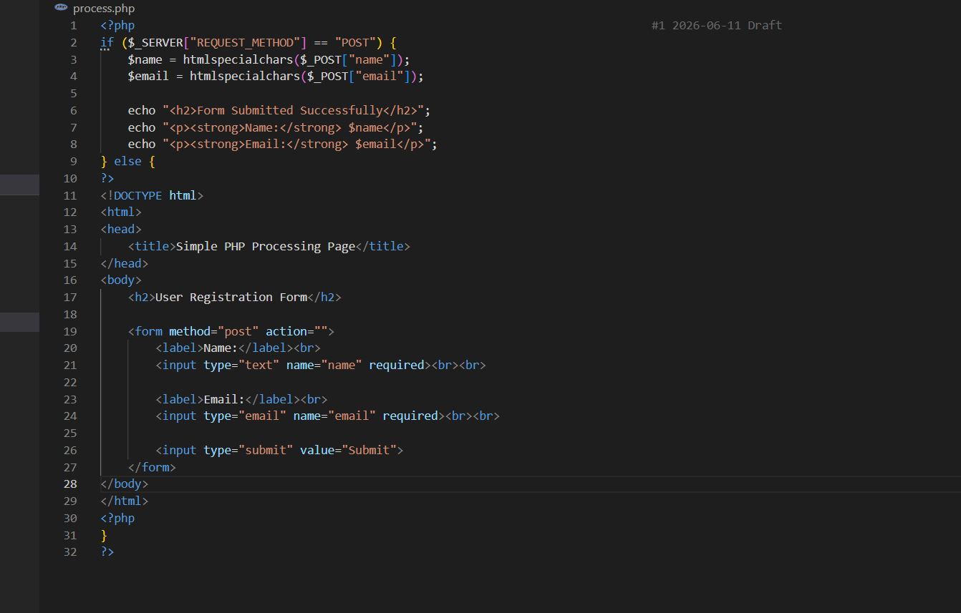
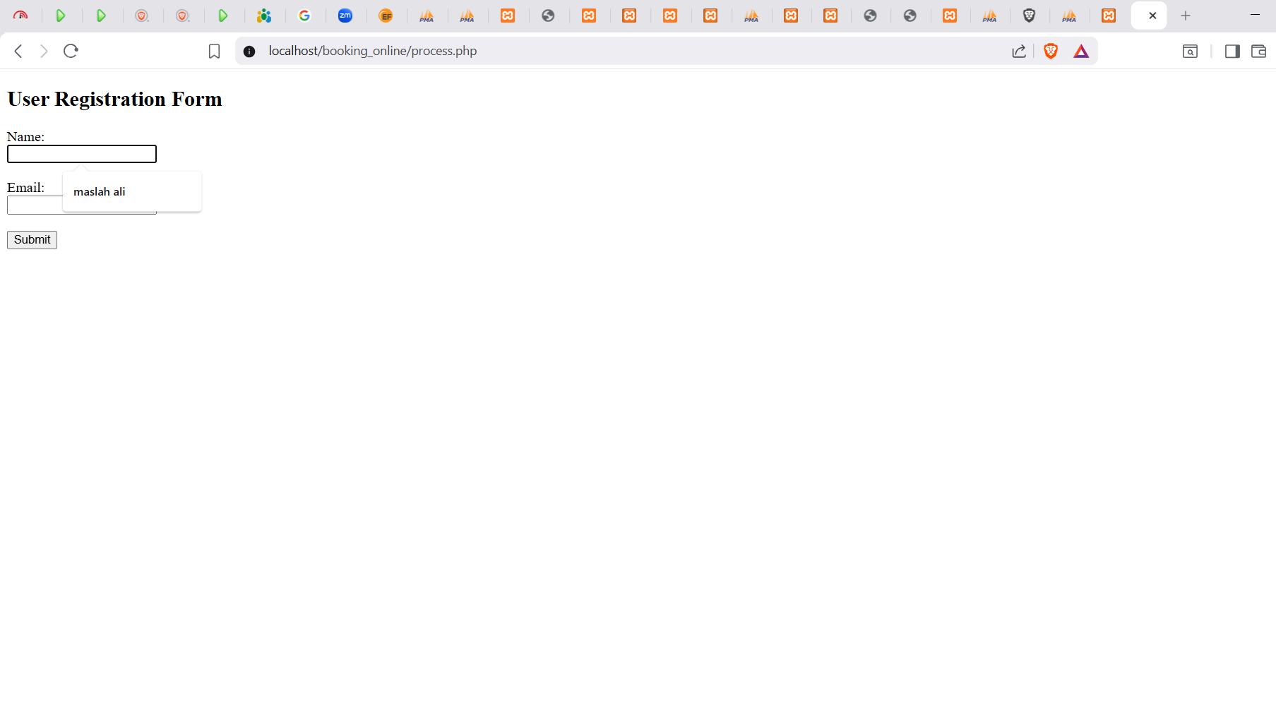

Fig 1: Simple PHP processing page
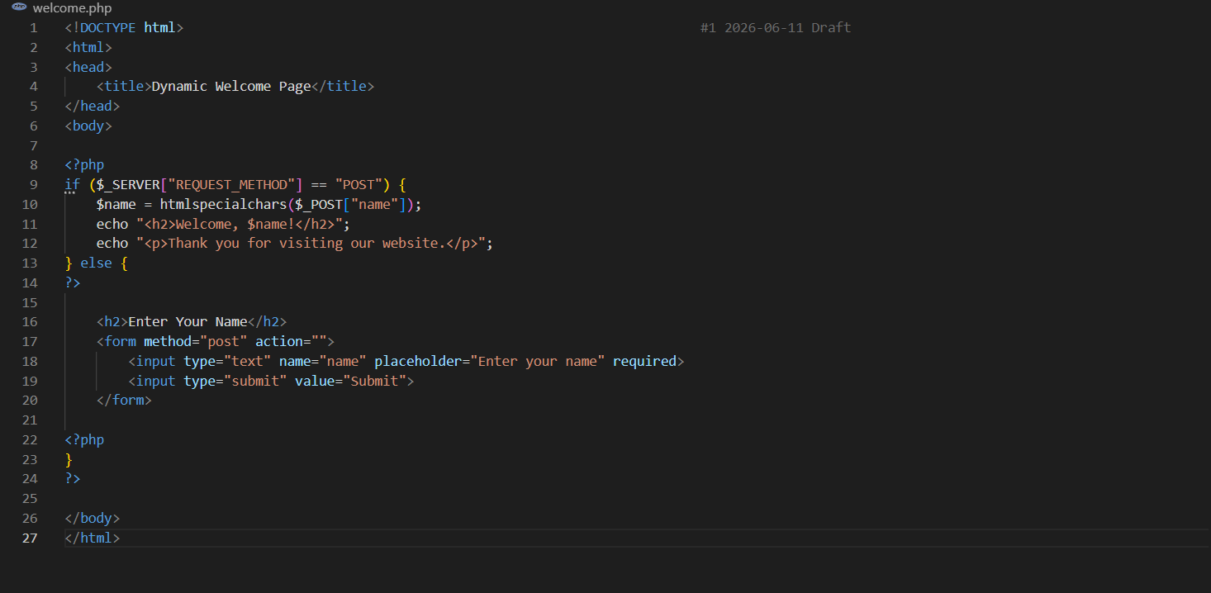
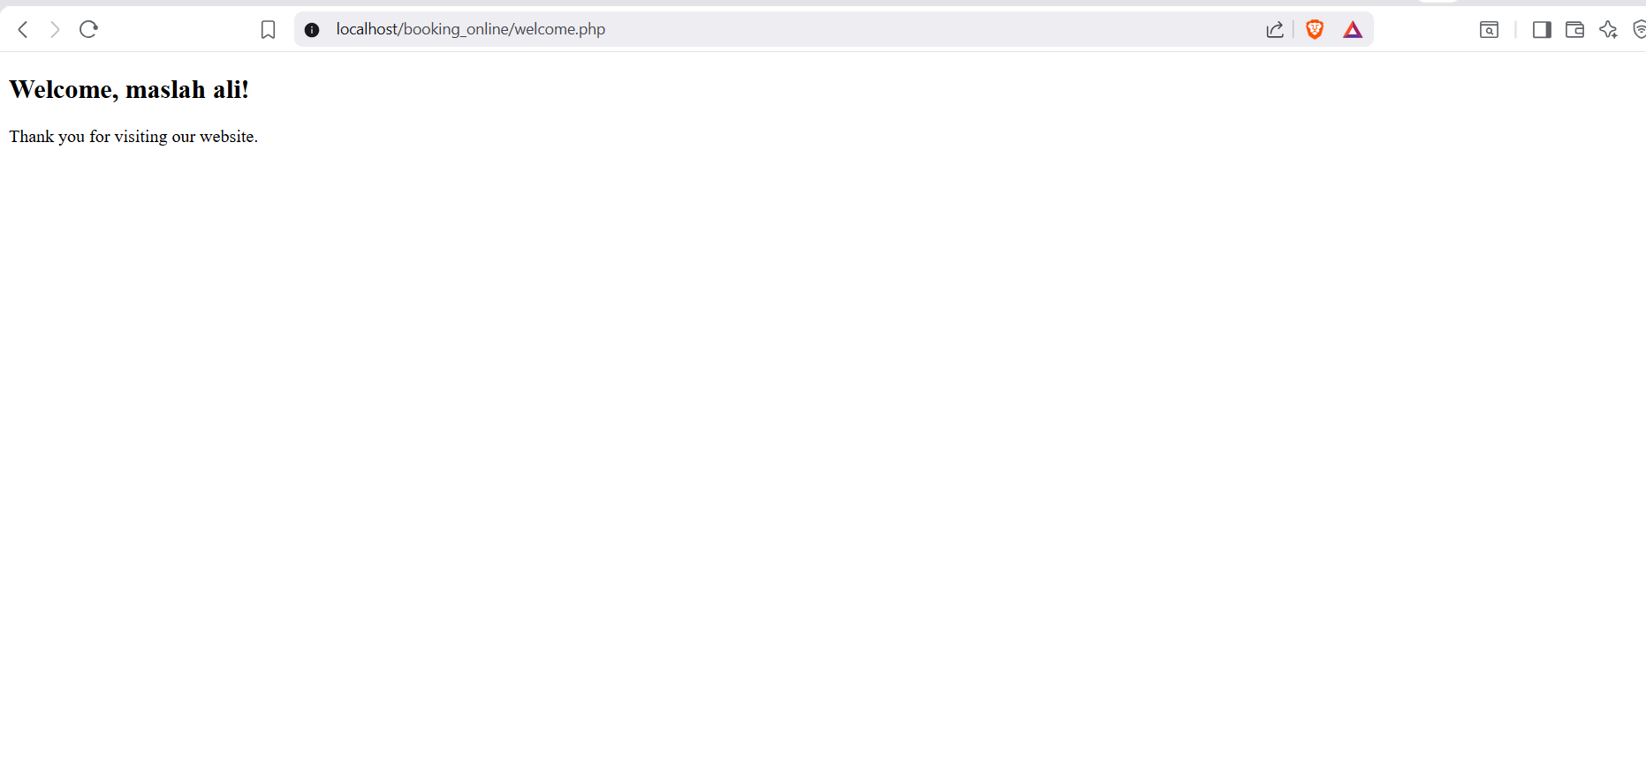

Fig 2:Dynamic welcome page
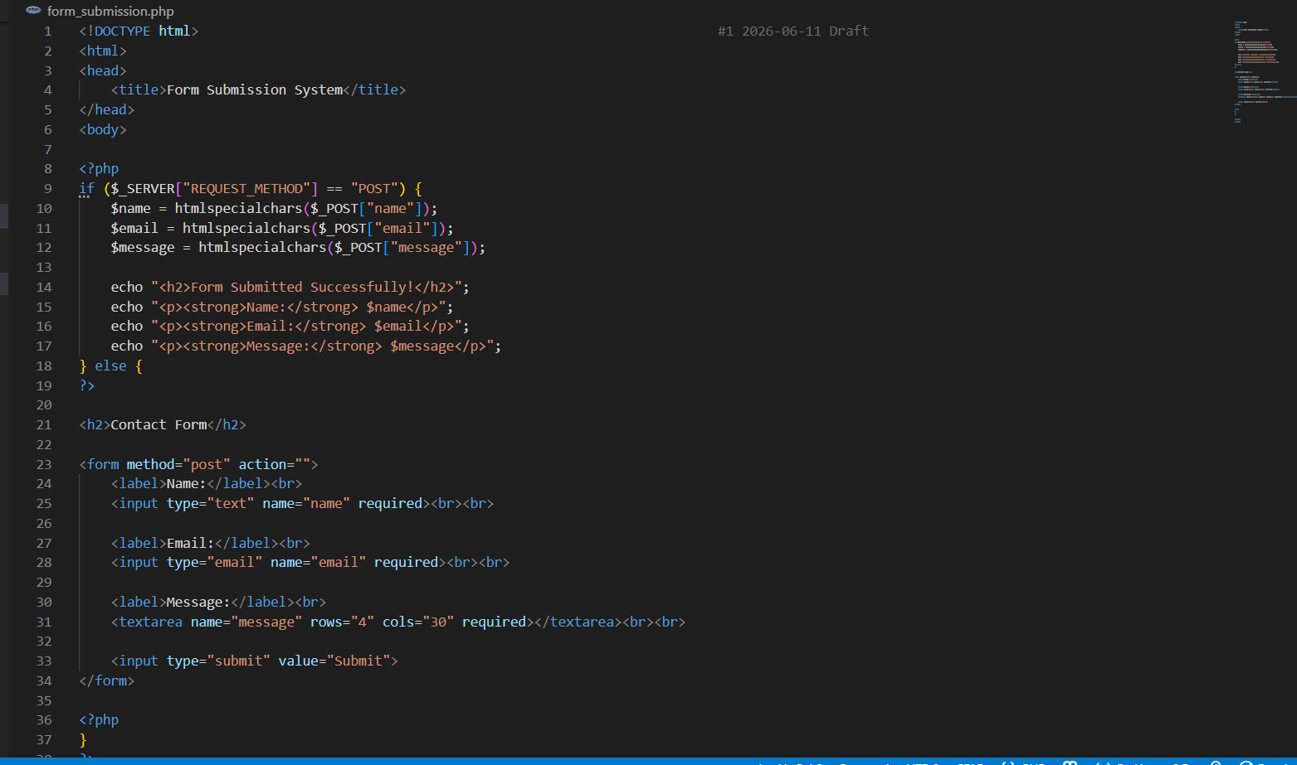
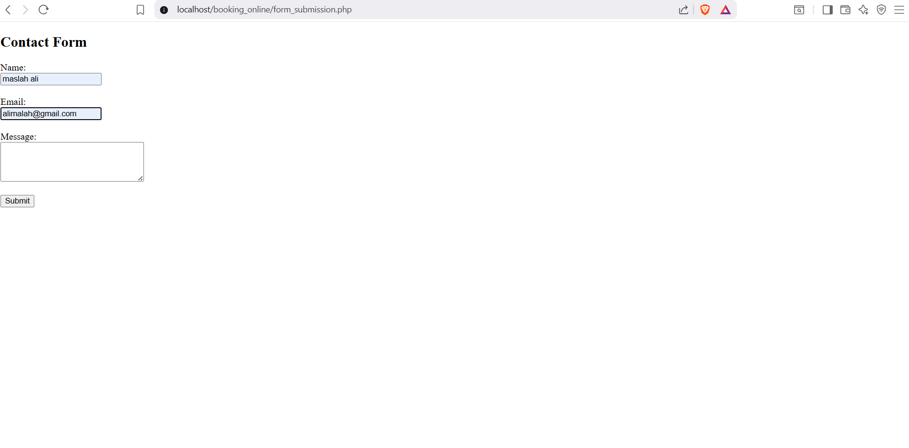

Fig 3:Form submission system

TASK 2-HTML Forms and PHP Integration
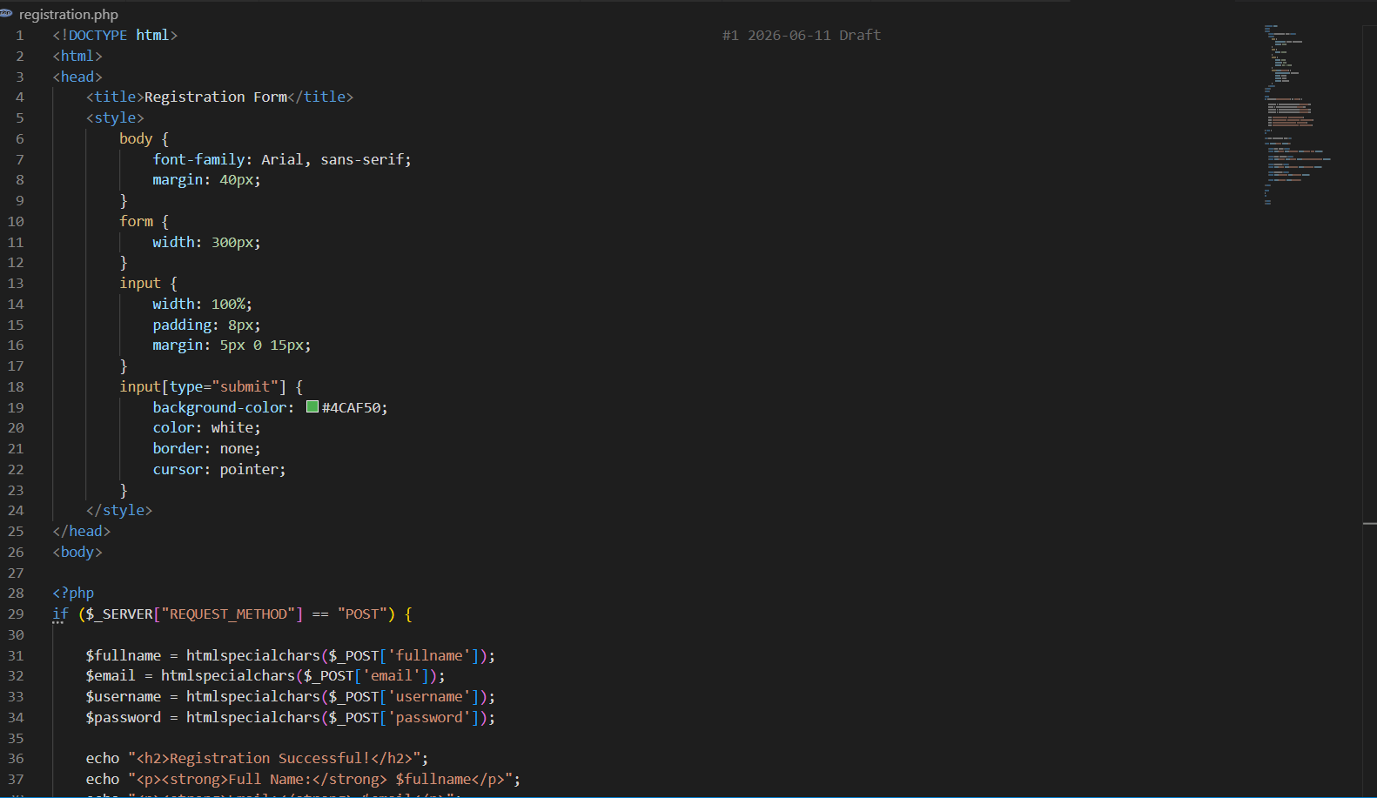
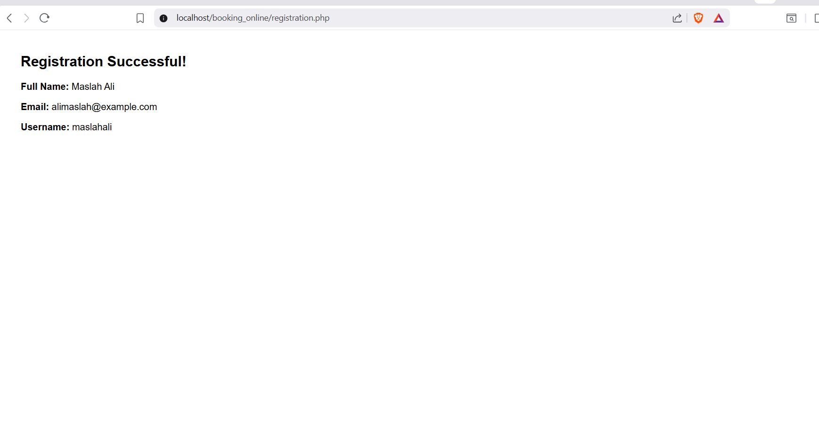

Fig 4:Registration form
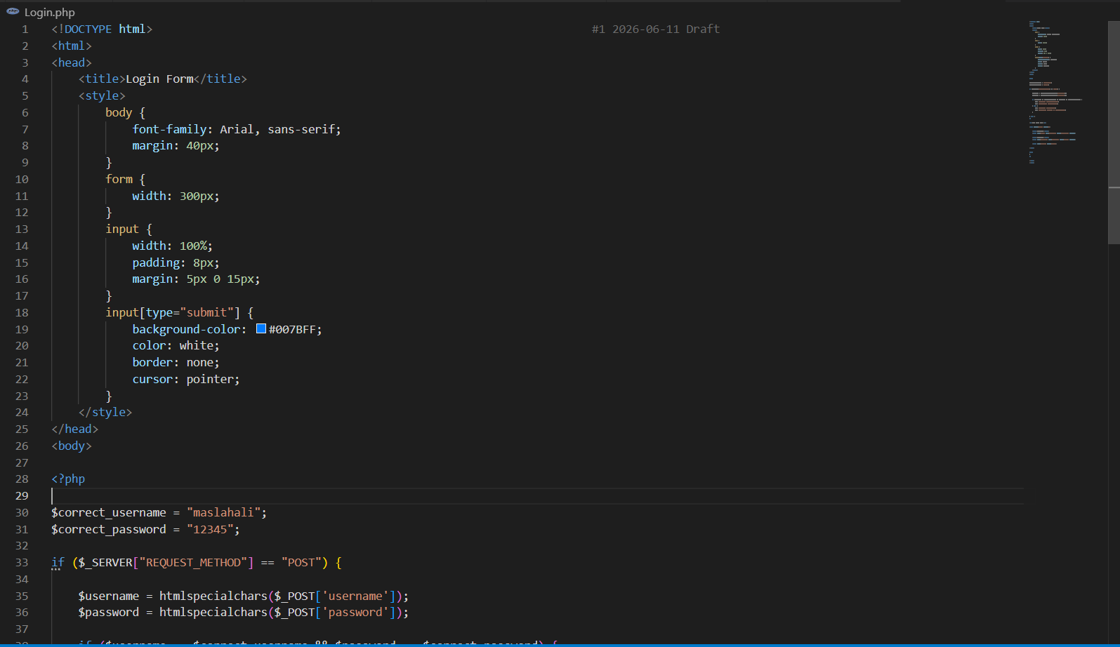
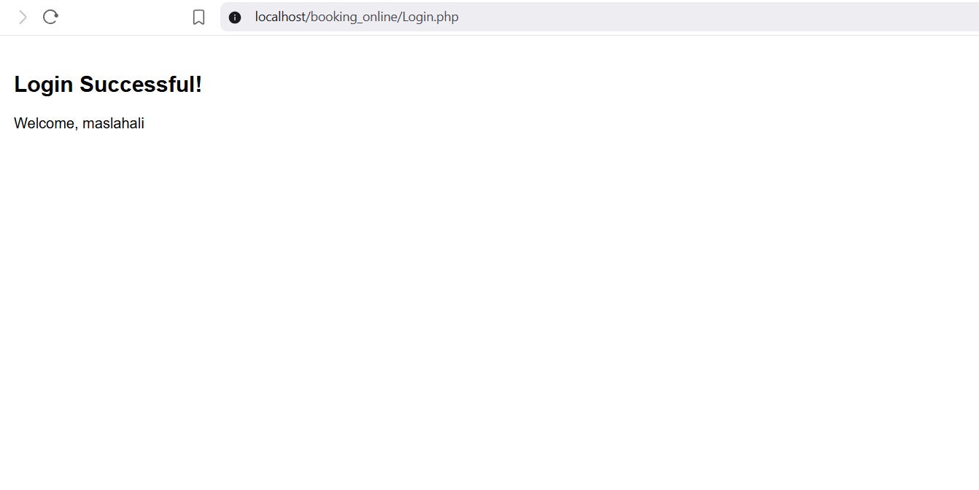

Fig 5:Login form

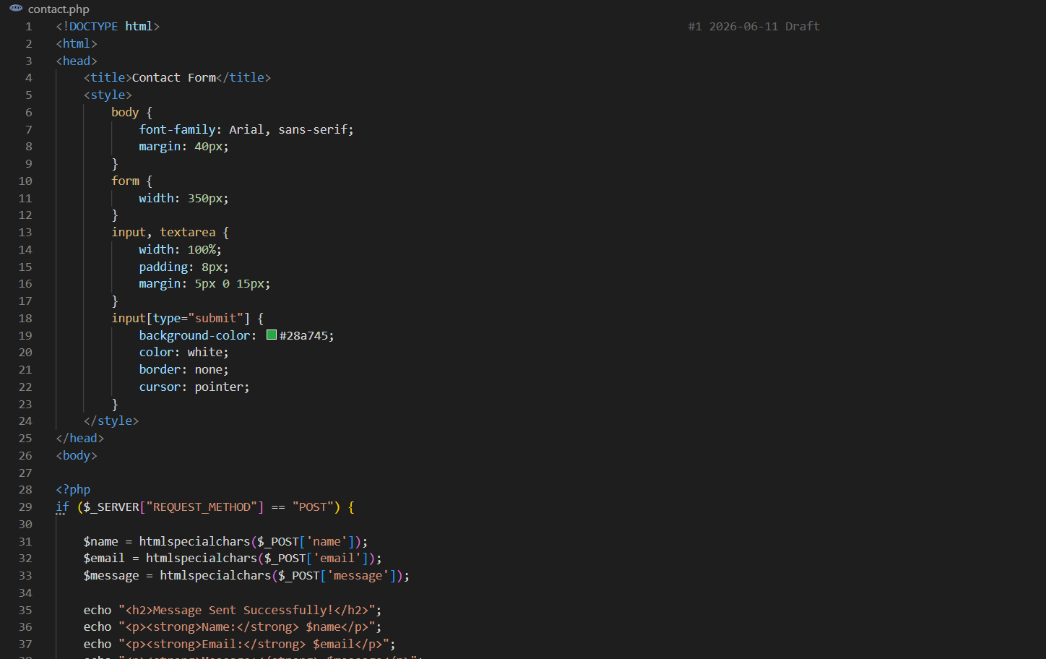
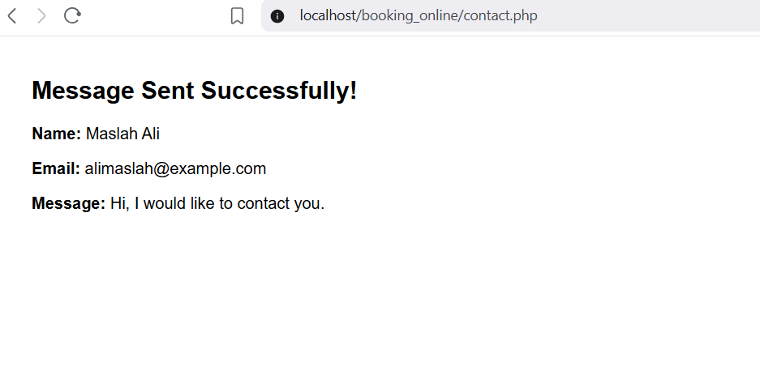

Fig 6:Contact form

Task 3-Simple Authentication System
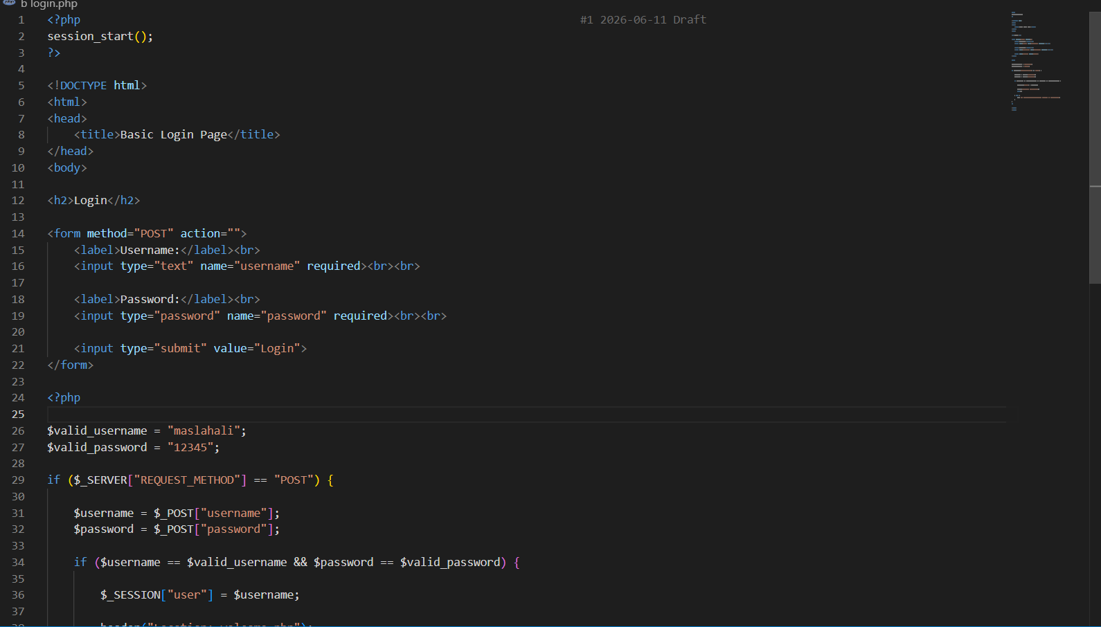

Fig 7:Basic login page
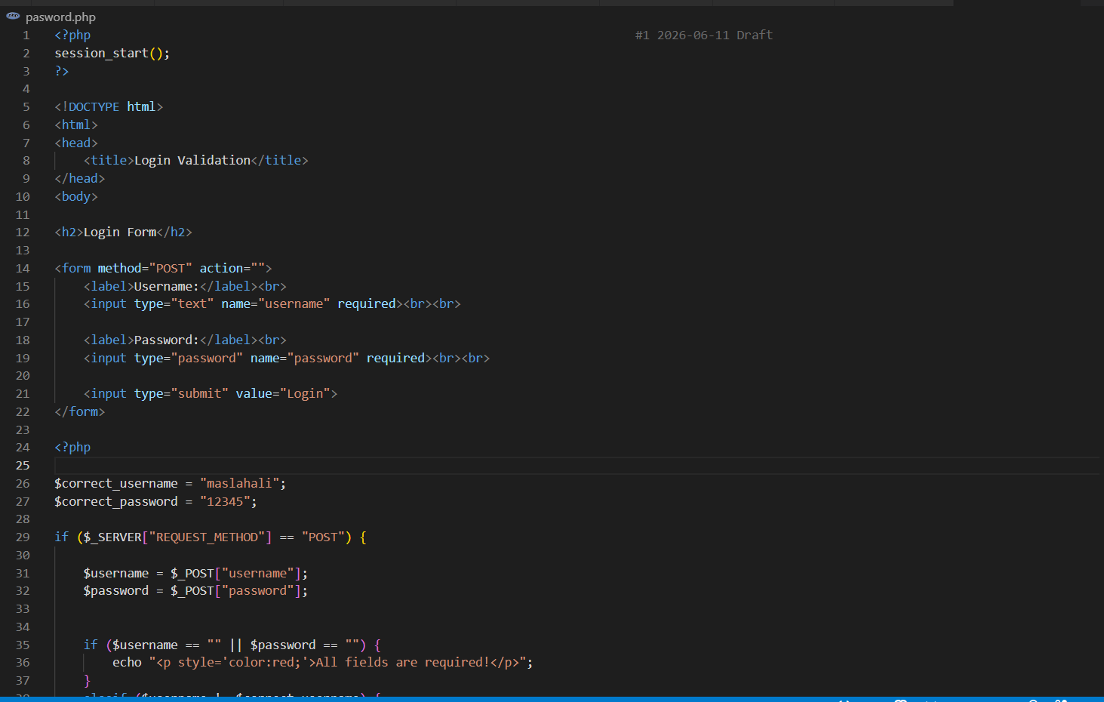

Fig 8:Username validation

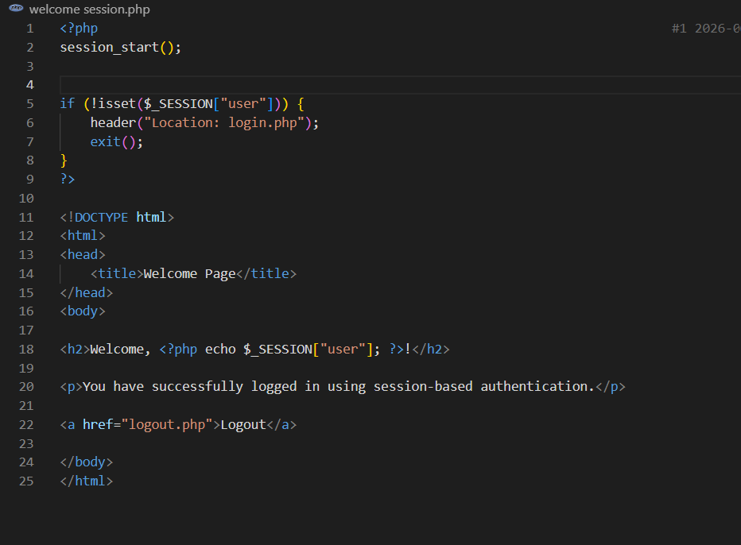

Fig 9:Session-based welcome page

WEEK 5: DATABASE COMPONENTS AND CRUD OPERATION
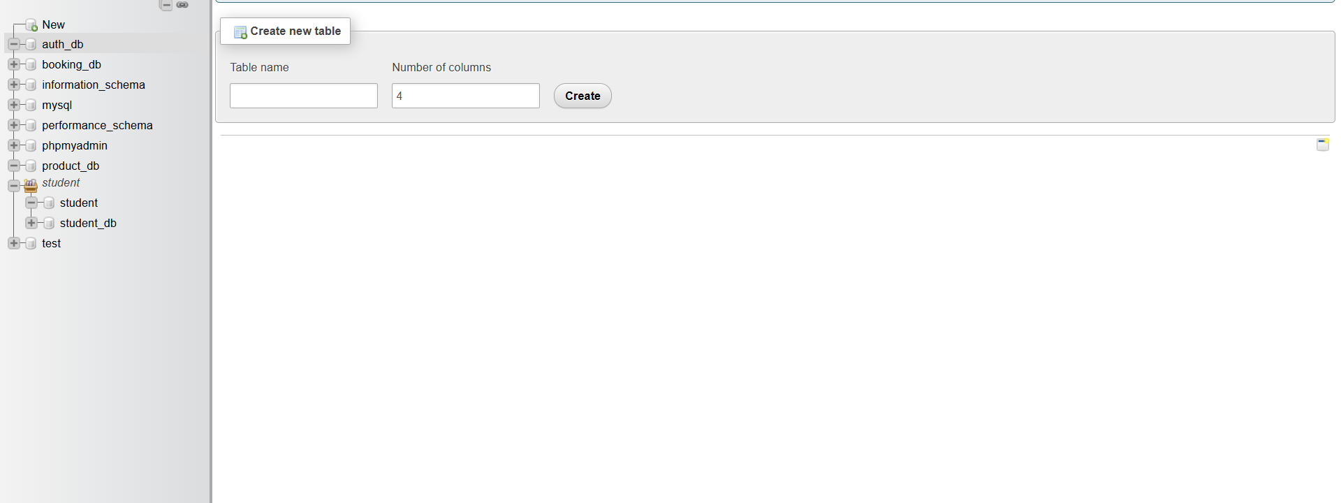
Fig 1:Databases

tables TASK 3-creating
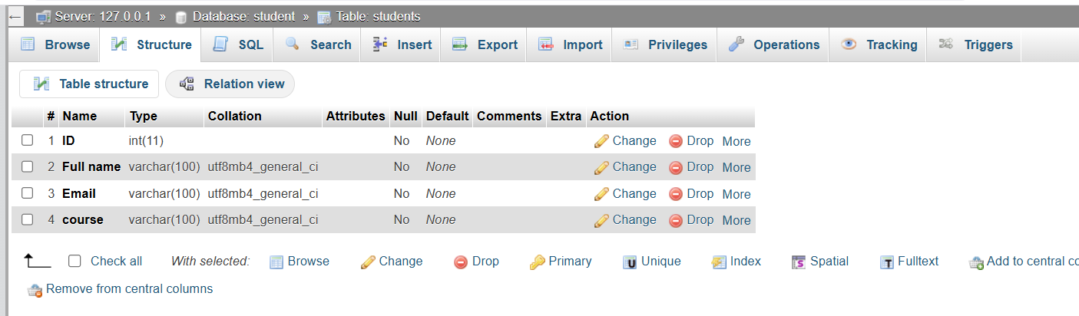

Fig 2:students table

Task 4-Crud operation
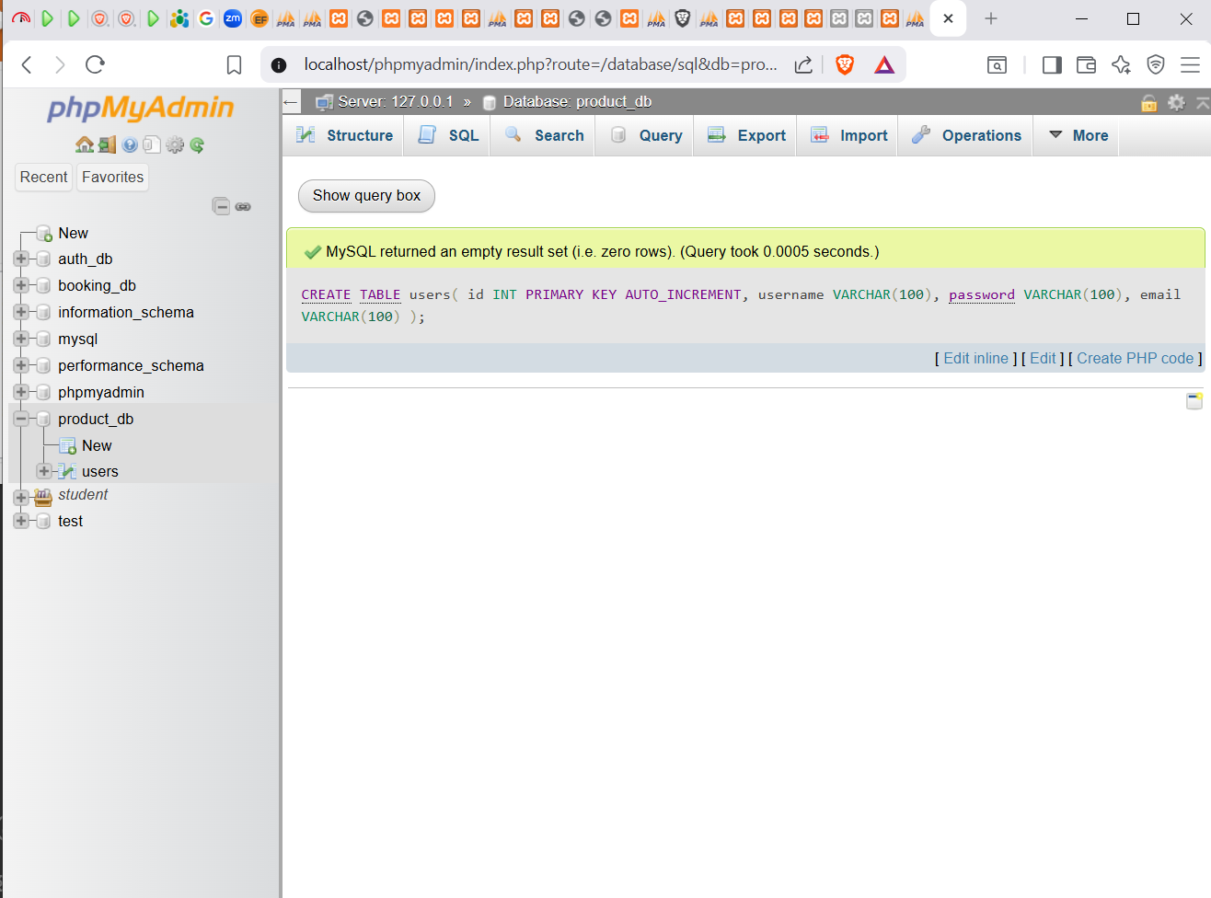
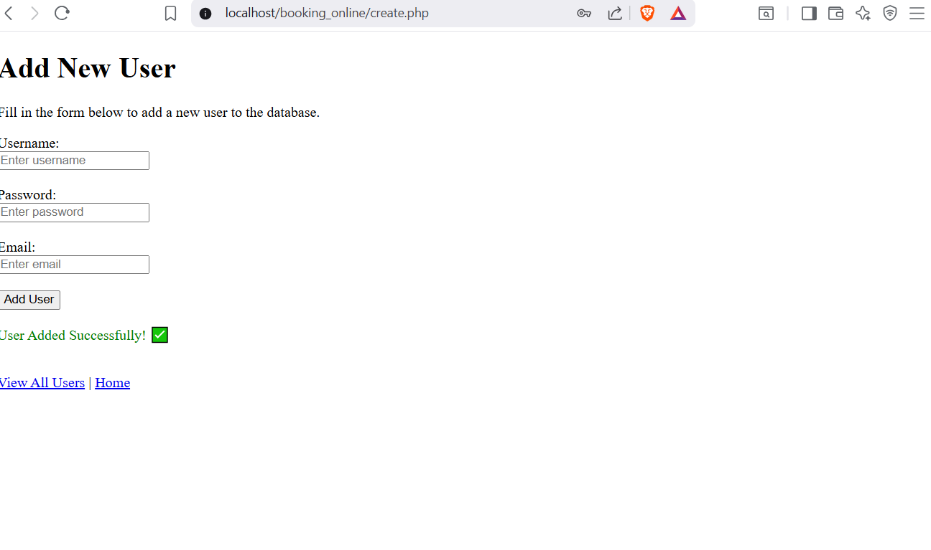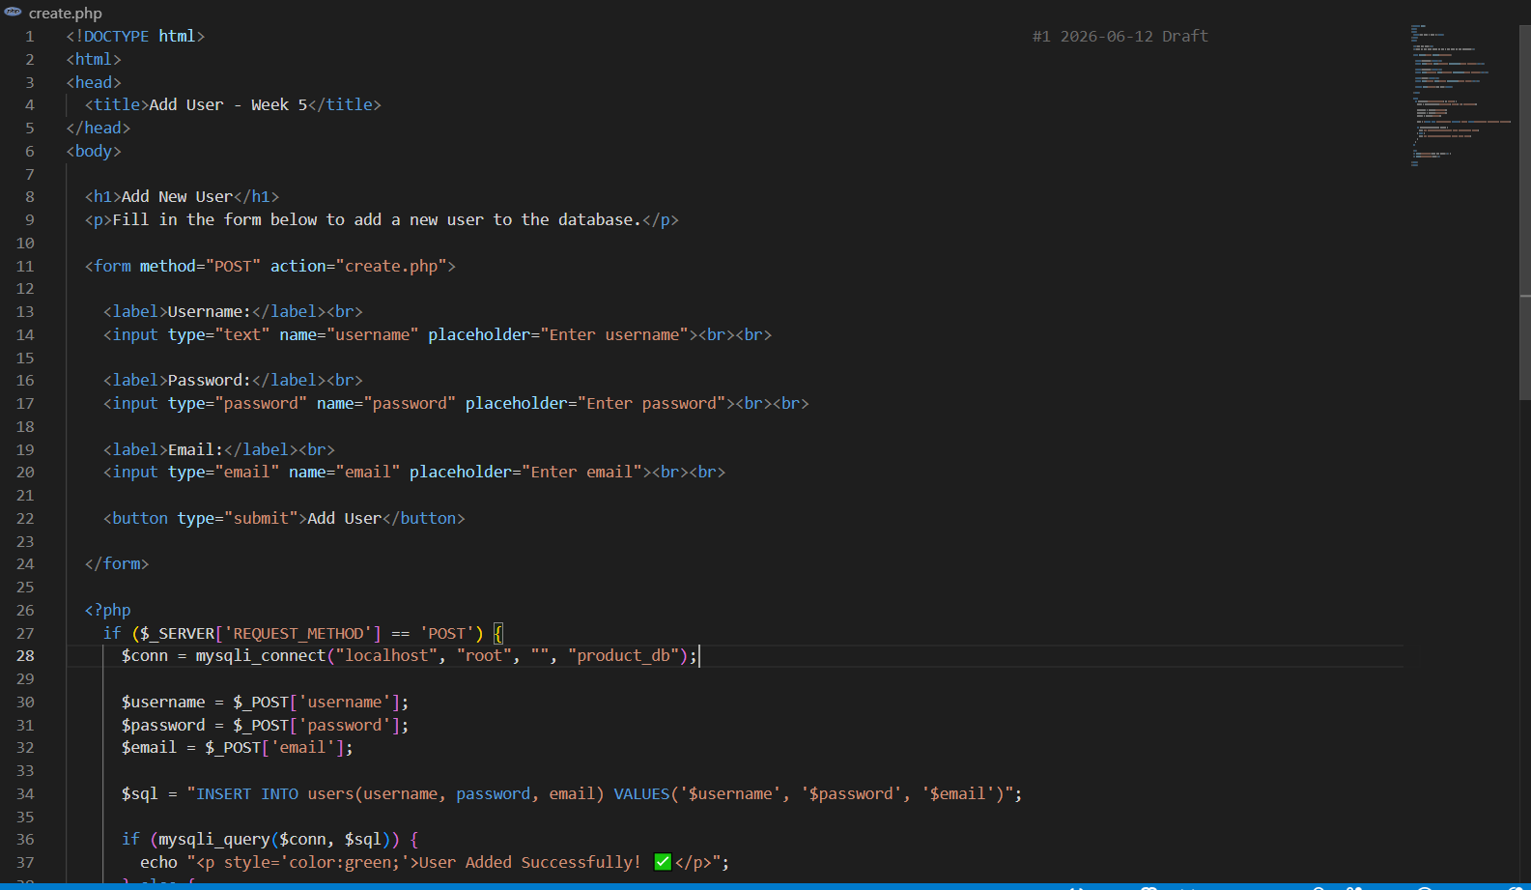

Fig 3:Adding new user
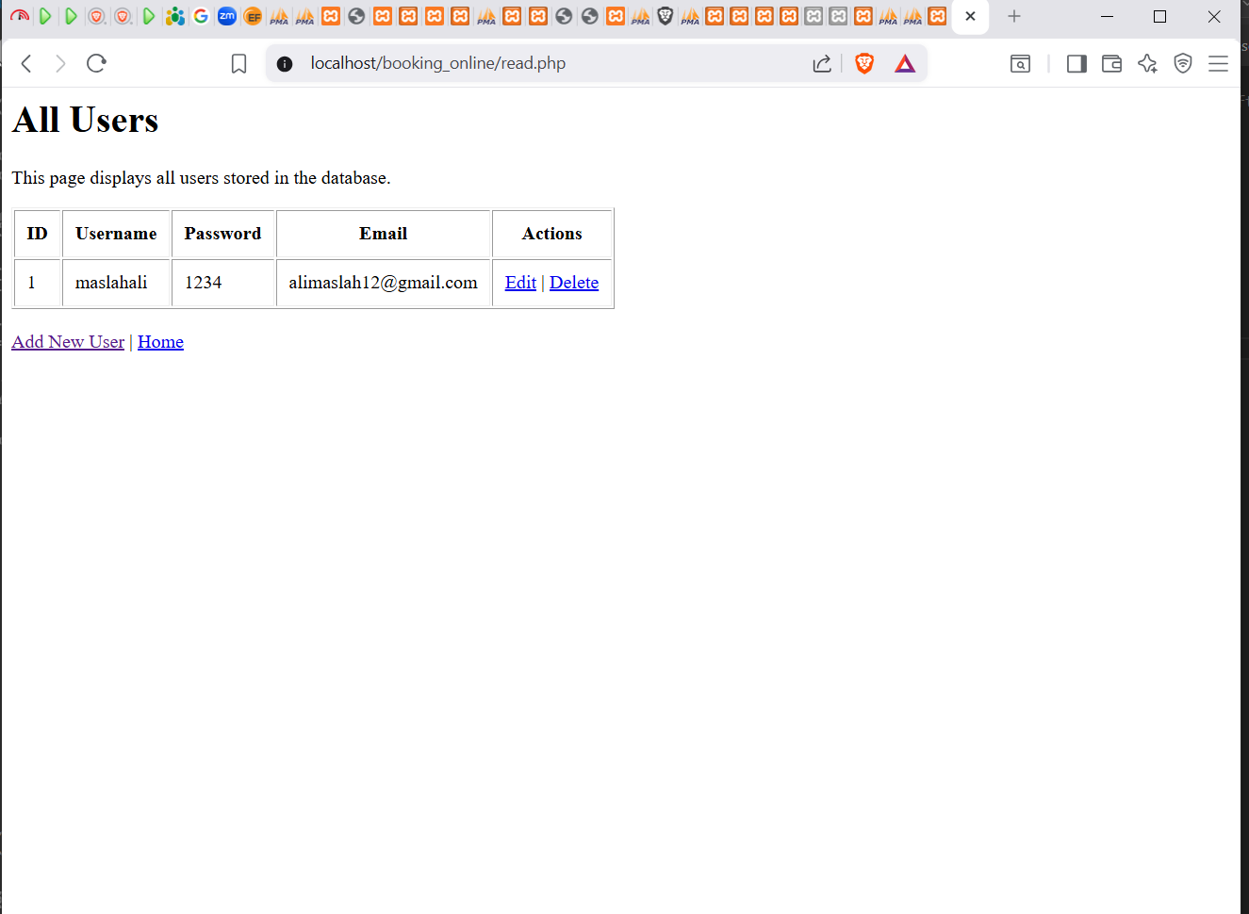

Fig 4:view all users
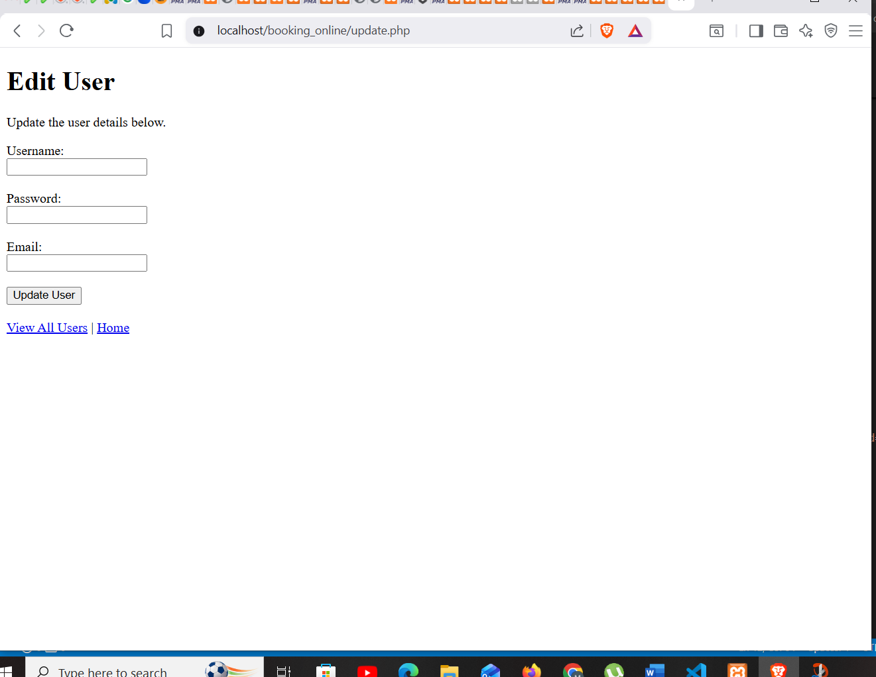
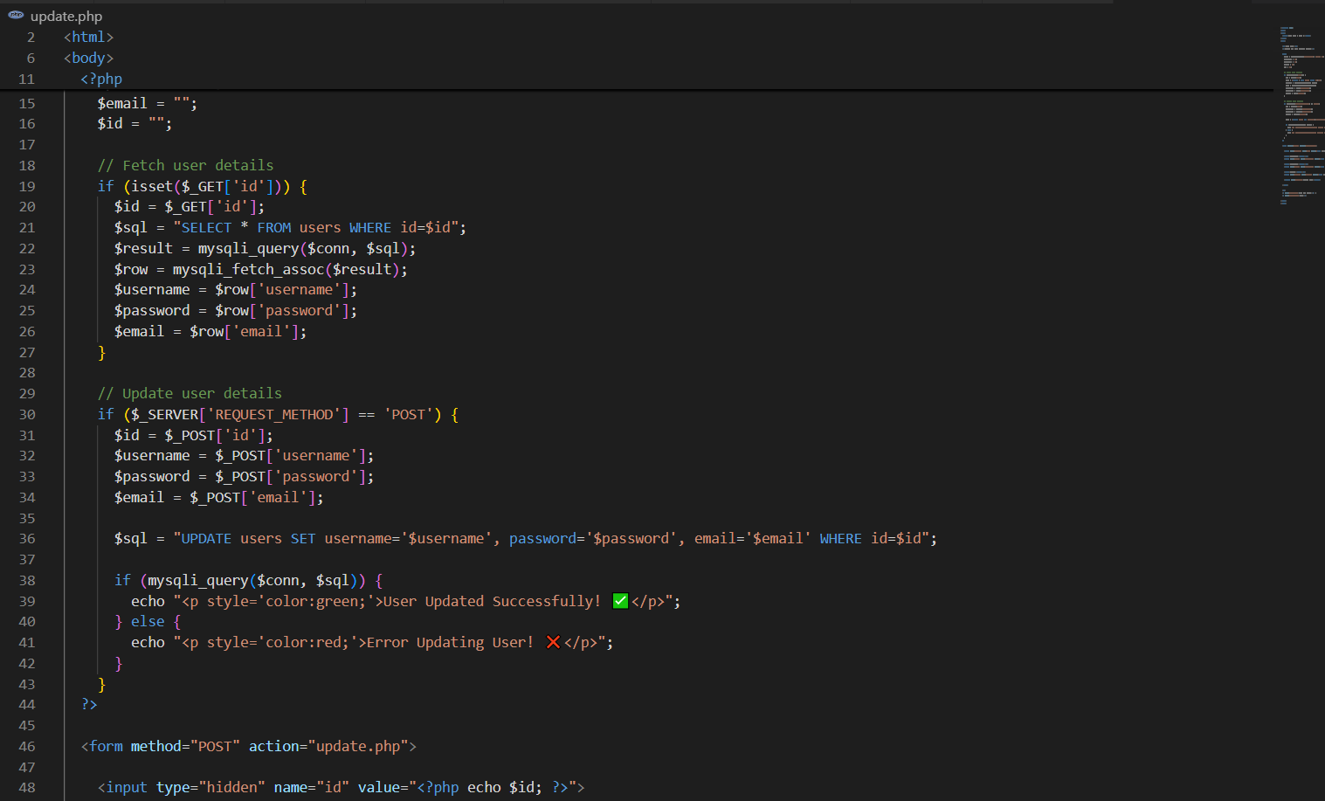

Fig 5:update user

